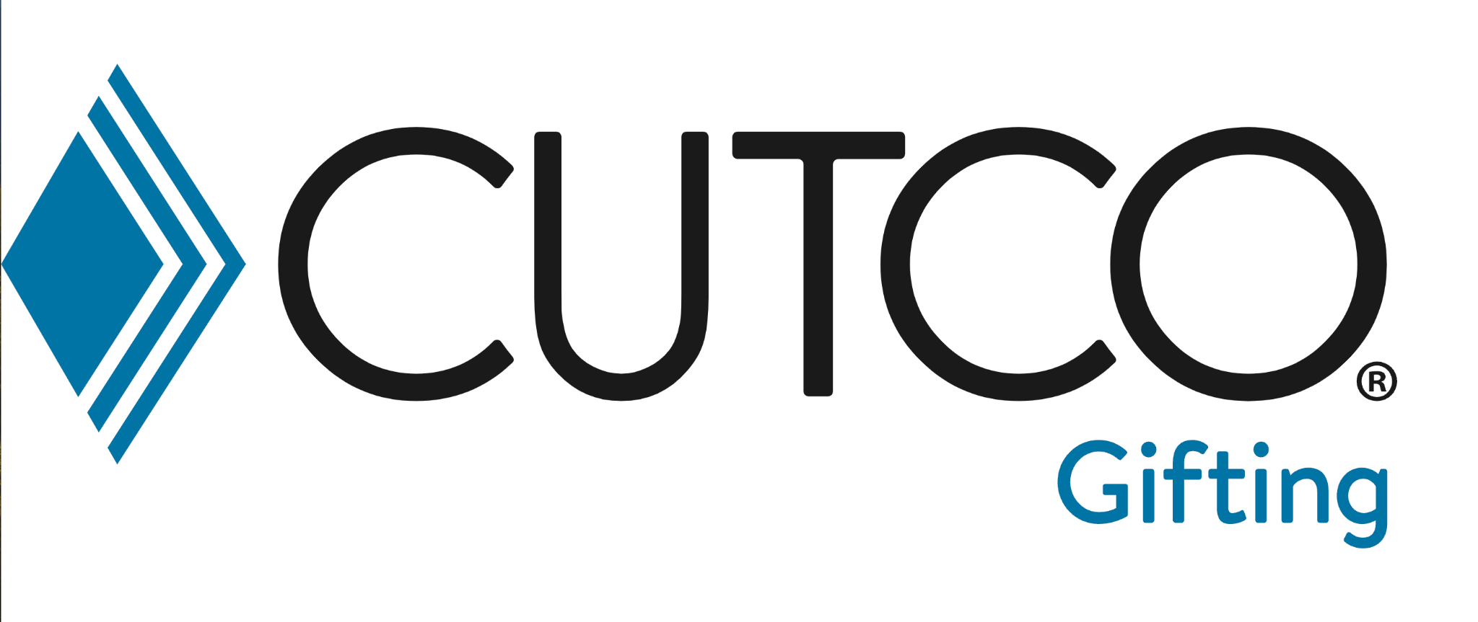

Dear Valued Client,
I’m excited to share this gift with you — the Cutco Pizza Cutter, a tool that’s as sturdy as it is fun to use. I’m giving you this lifetime quality gift because I truly value the lifelong relationship we’re building together.
This fan favorite is designed for more than just pizza night:
• Slice through thick or thin crust pizzas with ease.
• Works great on quesadillas, cookie cakes, or flatbreads.
• Large, durable blade stays sharp and resists wobbling.
• Blade separates from the handle for easy cleaning, and it’s dishwasher safe.
It’s one of those gifts that makes everyday meals just a little more fun. And like every piece of Cutco, it’s guaranteed forever, so you’ll enjoy it for a lifetime. This is another small way to remind you of my gratitude.
Like all Cutco cutlery, it’s Made in the USA and guaranteed forever, so you’ll enjoy it for a lifetime. This is another small way to remind you of my gratitude.
Warm regards,  Eric Chandler  Founder / CEO  Cutting Edge Gifts  1712 Foxwood Dr  Garner, NC 27529  m: 336.437.2102  I look forward to working with you and friends you send my way for years to come.  P.S. I'd really appreciate if you took a moment to click this QR code and leave a Google review for me — please and thank you. | 

